1) Database Architecture
Definition of Database Architecture
Database Architecture is the structure or design of a database system.
It tells how different parts like client, server, and database are connected and work together.
In simple words:
It is the blueprint of how a DBMS is organized.
Purpose of Database Architecture
- To design the database properly
- To manage data efficiently
- To improve performance
- To provide security
- To make maintenance easier
- To support multiple users
It helps developers understand where data is stored and how users access it.

2.1 One-Tier Architecture (Single Tier)
Definition
In One-Tier Architecture, client, server, and database are all on the same machine.
User directly works with the database.
Working
- Application and database are installed on one system
- User runs SQL queries directly
- No network is involved
Everything happens inside one computer.
Example
- Installing MySQL or Oracle on your laptop
- Practicing SQL queries in your system
Like when you use a database software in lab for learning.
Usage in Production
- Rarely used in real companies
- Not suitable for large systems
- Used mainly for learning and testing

2.2 Two-Tier Architecture
Definition
In Two-Tier Architecture, the client and database server are on different machines.
Client sends request to server, and server sends back data.
Layers (Client + Server)
- Client
  - User interface
  - Sends SQL queries
- Server
  - Stores database
  - Processes queries
Security Aspect
- Database is not directly exposed to users
- Only client can access the server
- More secure than one-tier
But still less secure than three-tier.
Communication Speed
- Direct communication between client and server
- Faster than three-tier in small systems
- Good for small to medium applications

2.3 Three-Tier Architecture
Definition
Three-Tier Architecture is the most common architecture.
It has three separate layers:
- Presentation layer
- Application layer
- Database layer
Each layer does a separate job.

Comparison with 2-Tier
Two-Tier | Three-Tier
Client talks directly to database | Client talks to application server
Less secure | More secure
Less scalable | More scalable
Simple structure | More structured
Three-tier adds one extra layer (application layer) for better control.
Layers
1) Presentation Layer
- User interface
- Example: Website, Mobile App
- Takes input from user
Example: Login page of a website.
2) Application Layer
- Contains business logic
- Processes user request
- Decides what data is needed
Example:
Checks username and password before asking database.
3) Database Server
- Stores data
- Executes SQL queries
- Returns required data
Example: MySQL or Oracle server storing user records.
Advantages of 3-Tier
- Better security
- Easy maintenance
- Easy to update one layer without affecting others
- Supports large number of users
- Good performance for large systems
Most modern web applications use three-tier architecture.

3. Centralized Systems
1. Introduction
A Centralized System is a computing system in which:
- All processing is done on one single computer
- All data is stored in one location
- The system does not depend on other computers
There is no distribution of processing or storage.
Everything is handled by one machine.
In database terms, a centralized DBMS runs entirely on one system.
2. General Structure of a Centralized Computer System
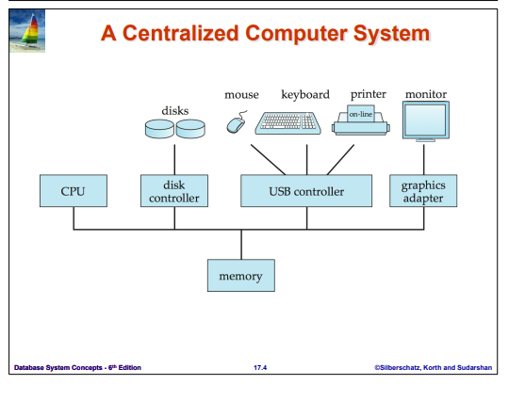
From the diagram, we can understand the internal structure.
A centralized system typically contains:
- CPU (Central Processing Unit)
- Main Memory
- Disks
- Device Controllers
- Input/Output devices
All components are connected using a common system bus.
3. Common Bus Architecture
The diagram shows that:
- CPU
- Memory
- Disk controller
- USB controller
- Graphics adapter
are connected through a common bus.
What is a Common Bus?
A common bus is a communication pathway that:
- Connects CPU, memory, and I/O devices
- Allows data transfer between components
- Provides shared access to memory
This means all devices use the same communication channel to interact with memory and CPU.
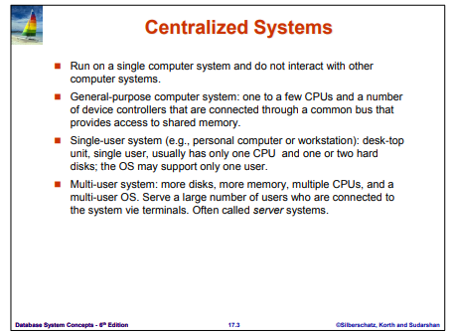
4. Main Components
4.1 CPU
- The brain of the system
- Executes instructions
- Processes data
- Controls other components
In centralized systems, there may be:
- One CPU (small systems)
- Multiple CPUs (large server systems)
4.2 Main Memory
- Temporary storage (RAM)
- Stores:
  - Running programs
  - Active data
- Shared by CPU and devices
All operations require access to memory.
4.3 Disk and Disk Controller
Disk
- Permanent storage
- Stores database files and system files
Disk Controller
- Manages read and write operations
- Acts as an interface between disk and CPU
The CPU does not directly access disk; it communicates through the controller.
4.4 USB Controller
- Connects input/output devices
- Examples:
  - Mouse
  - Keyboard
  - Printer
It manages communication between peripheral devices and system.
4.5 Graphics Adapter
- Connects to monitor
- Responsible for display output
- Converts processed data into visual output
5) Types of Centralized Systems
A centralized system can be classified based on how many users it supports at the same time.
5.1 Single-User System
Definition
A Single-User System is a centralized system designed to support only one user at a time.
This means:
- Only one person can actively use the system.
- All resources (CPU, memory, disk) are dedicated to that one user.
Technical Characteristics
• Usually has one CPU
→ One processor handles all operations.
• Limited memory (RAM)
→ Enough for personal tasks but not heavy multi-user load.
• One or two hard disks
→ Used for storing OS, applications, and user files.
• Operating system supports one active user session
→ Example: Windows Home edition.
• No need for complex resource scheduling
→ Since only one user is active.
How It Works
- User logs into the system.
- All programs and processes belong to that user.
- CPU executes instructions for that single user.
- No resource sharing between multiple users.
The system does not need to divide CPU time between different users.
Proper Example
Example 1: Personal Computer (PC)
Your home laptop:
- You install MySQL locally.
- You run SQL queries.
- Database files are stored on your own hard disk.
- No other user is accessing your system at the same time.
Everything is processed locally.
Example 2: Workstation in Small Office
In a small shop:
- One employee uses a computer for billing.
- The database is stored on that same machine.
- Only that employee accesses the system.
This is centralized and single-user.
Limitations
- Cannot handle multiple users
- Not suitable for large organizations
- If system crashes → work stops
5.2 Multi-User System
Definition
A Multi-User System is a centralized system that supports multiple users at the same time.
Many users connect to the same central machine.
Technical Characteristics
• Multiple CPUs (or multi-core processors)
→ To handle many users simultaneously.
• Large memory (RAM)
→ To support multiple processes.
• Multiple hard disks
→ For high storage and faster data access.
• Multi-user operating system
→ Example: Linux Server, UNIX, Windows Server.
• Time-sharing mechanism
→ CPU time is divided among users.
How It Works
- Multiple users connect to the central system.
- Each user runs applications.
- Operating system manages:
  - CPU scheduling
  - Memory allocation
  - Disk access
- All users share the same hardware.
The system uses time-sharing to give each user CPU time.
Even though CPU is single or limited, it switches very fast between users.
What Are Terminals?
Users do not directly use the main server machine physically.
They connect through:
- Terminals
- Thin clients
- Remote desktop
- Network connections
The actual processing happens on the central server.
Proper Example
Example 1: University Database Server
In a university:
- 200 students log into a lab system.
- All students run SQL queries.
- Database is stored on one central server.
- Server has:
  - Multiple CPUs
  - Large RAM
  - Multiple storage drives
All students share the same machine.
If the server crashes → all students lose access.
Example 2: Bank Core Banking Server
In a bank:
- All branch employees connect to the same central server.
- Customer account data is stored on one main system.
- All transactions are processed centrally.
This is centralized and multi-user.
Why It Is Called Server System
Because:
- It serves multiple users.
- It provides services (data, processing).
- Users act as clients or terminals.
Advantages of Multi-User Centralized System
• Efficient resource usage
• Centralized control
• Easy backup and security management
• Suitable for medium organizations
Disadvantages
• Single point of failure
• Performance decreases if too many users connect
• Limited scalability compared to distributed systems
6. Working of a Centralized System
Step-by-step flow:
- User gives input (keyboard/mouse)
- Input goes to CPU via controller
- CPU processes request
- If needed, data is fetched from disk
- Data is loaded into memory
- CPU processes data
- Output sent to monitor or printer
All processing happens inside one machine.
There is no remote server involved.
7. Characteristics of Centralized Systems
- Single location of data
- Single system control
- Shared memory model
- Simple architecture
- No network dependency (in basic form)
8. Advantages
- Simple design
- Easy to manage
- Easy backup and control
- Lower maintenance cost
- No network communication delay
9. Disadvantages
- Single point of failure
  - If system crashes, everything stops
- Limited scalability
  - Hard to expand for large systems
- Performance bottleneck
  - Heavy traffic slows system
- Not suitable for geographically distributed organizations

Client-Server Systems
1. Introduction
A Client-Server System is a computing architecture where:
- Multiple client systems generate requests
- A central server system processes those requests
- Communication happens through a network
In simple words:
Clients ask for services.
Server provides those services.
This model is widely used in modern database systems.
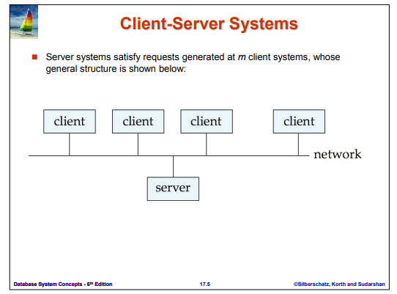
2. Basic Structure (Explanation of Diagram)
The diagram shows:
- Several boxes labeled client
- All connected to a network
- One server connected to the same network
This means:
- There are m client systems
- One server system
- All communication happens via network
Here, m means any number of clients (2, 10, 100, etc.).
The server satisfies requests generated by all these clients.
3. Components of Client-Server Architecture
3.1 Client
A client is:
- A personal computer
- A laptop
- A mobile device
- A terminal
The client usually handles:
- User interface
- Input from user
- Sending requests to server
- Displaying results
The client does NOT usually store the main database.
It mainly acts as a front-end.
3.2 Server
The server is:
- A powerful machine
- Stores database
- Runs DBMS software
- Handles multiple client requests
The server is responsible for:
- Query processing
- Transaction management
- Concurrency control
- Security enforcement
- Data storage
It is called a back-end system.
3.3 Network
The network connects clients and server.
It can be:
- LAN (inside an office or university)
- WAN (between cities)
- Internet
All requests and responses travel through the network.
4. Working of Client-Server System
The working process is as follows:
- User enters input on client machine.
- Client converts input into request (for example SQL query).
- Request is sent to server through network.
- Server receives request.
- Server processes the request using DBMS.
- Server sends result back through network.
- Client displays the result to user.
Important point:
Processing is divided between client and server.
5. Logical View
Logically, the system has two main parts:
- Client (presentation side)
- Server (data processing side)
This separation improves control and efficiency.
6. Why Client-Server Model is Used
Centralized systems become inefficient when:
- Many users need access
- Systems are geographically separated
- Workload increases
Client-server solves this by:
- Allowing multiple clients
- Centralizing data storage
- Using network communication
7. Example 1 – University Database System
In a university:
- 100 students use lab computers
- Each lab computer acts as a client
- All connect to one database server
When a student runs a query:
- Client sends SQL to server
- Server executes query
- Result is returned
All students share the same central database.
8. Example 2 – ATM Banking System
When you withdraw money from ATM:
- ATM = Client
- Bank central system = Server
- Internet/Network connects them
Steps:
- You enter PIN.
- ATM sends request to bank server.
- Server verifies account details.
- Server approves or rejects transaction.
- ATM shows result.
All actual data processing happens at server.
9. Advantages of Client-Server System
- Centralized control of data
- Better security than simple standalone systems
- Supports multiple users
- Efficient data management
- Easy backup (only server needs backup)
- Scalable compared to single-machine systems
10. Disadvantages
- Server is a single point of failure
- Network failure stops communication
- High initial setup cost
- Requires skilled administration

5) Distributed Database
5.1 Definition
A Distributed Database is a database system in which:
- The database is not stored at a single location
- It is divided into two or more database files
- These files are stored at different physical locations
- All locations are connected through a network
Even though data is physically distributed, logically it appears as one single database to the user.
Key Idea
Distributed Database =
Multiple database locations + Network connection + One logical system
Database Files at Multiple Locations
In a distributed database:
- Data is split into parts
- Each part is stored at different sites (branches, cities, countries)
- Each site may store:
  - Complete database copy (replication)
  - Partial data (fragmentation)
Example:
A bank with branches in:
- Karachi
- Lahore
- Islamabad
Each branch may store:
- Local customer data
- Some shared data
All branches are connected through network.
Network-Based Access
All sites communicate using a network:
- LAN (within organization)
- WAN (between cities)
- Internet (global systems)
When a user sends a request:
- The system determines which site has the required data
- Retrieves it through the network
- Combines results if needed
User does not need to know where data is stored.
5.2 Features of Distributed Database
1) Local Access
Users usually access the nearest database site.
Example:
A student in Lahore accesses the Lahore server instead of Karachi server.
Benefits:
- Reduced network traffic
- Lower delay
- Better performance
2) Speed Improvement
Accessing nearby data increases speed because:
- Data retrieval is local
- Less network delay
- Parallel processing is possible
If different users access different sites, load is distributed.
This improves overall system performance.
3) Fault Tolerance
If one database site fails:
- Other sites continue working
- System does not completely stop
Example:
If Karachi server crashes,
Lahore and Islamabad servers can still function.
This improves system reliability.
4) Multi-User Access
Distributed systems support:
- Multiple users
- From different geographical locations
- Accessing different parts of database simultaneously
Concurrency control ensures:
- Data consistency
- No conflicts during updates
5.3 Comparison: Centralized vs Distributed Database
Centralized Database
Definition:
A database that contains a single database located at one location in the network.
Characteristics:
• Only one database file
• Easy to manage and update
• Easy backup process
• All users access the same database
Disadvantages:
• Access may become slow if many users access simultaneously
• If database fails → entire system stops
• Single point of failure
Data Consistency:
- Higher consistency
- Complete view of data
- No replication conflicts
Distributed Database
Definition:
A database that contains two or more database files located at different locations in the network.
Characteristics:
• Multiple database sites
• Data synchronization required
• Data may be replicated
Advantages:
• Faster access (nearest database file used)
• Better availability
• System continues even if one site fails
Disadvantages:
• Requires synchronization
• Complex management
• Possible data inconsistency
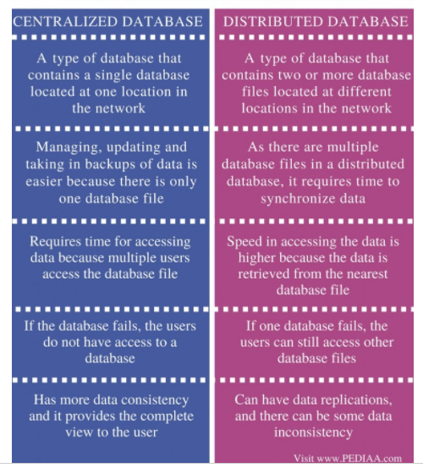
6) Distributed Database Architecture
Distributed Database Architecture explains how multiple database sites are organized and how they interact in a distributed environment.
There are two main types:
- Homogeneous Distributed Databases
- Heterogeneous Distributed Databases
6.1 Homogeneous Distributed Databases
Definition
A homogeneous distributed database is a distributed system in which:
- All sites use the same DBMS software
- All sites use the same data model
- All sites are aware of each other
- They cooperate to process user requests
To the user, the system behaves like one single database.
Main Points
1) Identical Software
All database sites use:
- Same DBMS (e.g., all use Oracle or all use MySQL)
- Same query language (SQL)
- Same data model (usually relational)
Because software is identical, communication and integration between sites is easier.
2) Cooperation Between Sites
All sites:
- Share information
- Work together to process queries
- Coordinate during distributed transactions
If a query requires data from multiple sites, each site processes its part and sends results back.
3) Reduced Autonomy
Autonomy means independence.
In homogeneous systems:
- A site cannot freely change its schema
- A site cannot change DBMS software independently
- Changes must be consistent across all sites
So individual control is reduced for the sake of uniformity.
4) Appears as Single System
The system provides distribution transparency:
- User does not know where data is physically stored
- System hides distribution complexity
- It looks like one centralized database
Example
A company with branches in different cities:
- All branches use the same DBMS
- Same database structure
- All connected through network
Users access data without knowing which branch stores it.
6.2 Heterogeneous Distributed Databases
Definition
A heterogeneous distributed database is a distributed system where:
- Different sites use different DBMS software
- Schemas may differ
- Data models may differ
- Sites may not fully cooperate
This makes the system more complex.
Main Points
1) Different Schemas
Each site may have:
- Different table names
- Different attributes
- Different structures
This creates difficulty in combining and processing data.
2) Different Software
Sites may use:
- Oracle
- MySQL
- SQL Server
- Other DBMS
Because internal mechanisms differ, integration becomes complex.
3) Query Processing Issues
When a query is sent:
- It may need translation for different DBMS
- Data formats may need conversion
- Schema mapping is required
This increases processing complexity.
4) Transaction Processing Issues
Maintaining consistency across sites is difficult because:
- Different DBMS handle transactions differently
- Coordinating commit or rollback is complex
- Global concurrency control is harder
Special protocols (like two-phase commit) are required.
5) Limited Cooperation
Some sites:
- May not share full control
- May restrict access
- May operate independently
So coordination is weaker compared to homogeneous systems.
Example
Two companies merge:
- One uses Oracle
- Other uses MySQL
- Database structures are different
Instead of redesigning everything, they connect systems — forming a heterogeneous distributed database.

8) Distributed Data Storage
Distributed Data Storage explains how data is physically stored across different sites in a distributed database system.
There are three main approaches:
- Replication
- Fragmentation
- Combination of both

8.1 Replication
Definition
Replication means storing multiple copies of the same data at different sites.
Main Points
1) Multiple Copies
The same relation or database fragment is stored at more than one location.
2) Faster Retrieval
Users can access the nearest copy, which reduces access time.
3) Fault Tolerance
If one site fails, another copy is still available.
This increases availability and reliability.
(Details of full replication and partial replication are discussed later.)
8.2 Fragmentation
Definition
Fragmentation means dividing a relation (table) into smaller parts called fragments.
Each fragment is stored at different sites.
Main Points
1) Partitioning Relation
A table is divided into parts:
- By rows (Horizontal Fragmentation)
- By columns (Vertical Fragmentation)
2) Stored at Distinct Sites
Each fragment is placed at different physical locations depending on usage.
This helps improve performance and manage local data access.
(Detailed types discussed later.)
8.3 Combination of Replication and Fragmentation
In real systems:
- A table may first be fragmented
- Then each fragment may be replicated
This means:
Fragmentation → divide data
Replication → copy fragments
This approach improves:
- Performance
- Availability
- Reliability
But it increases system complexity.

9) Data Replication
9.1 Definition
Data Replication is a technique in distributed databases where:
- A relation (table) or a fragment of a relation
- Is stored in two or more sites
This means the same data exists in multiple locations.
Purpose:
- Improve availability
- Improve performance
- Increase reliability
9.2 Full Replication
Full Replication means:
- The entire relation (complete table)
- Is stored at all sites in the distributed system
So every site has a complete copy of that table.
Example:
If there are 3 sites (Karachi, Lahore, Islamabad),
each site stores the full “Customer” table.
9.3 Fully Redundant Database
A Fully Redundant Database is a system where:
- Every site contains a copy of the entire database, not just one table.
This is the extreme form of replication.
Difference:
- Full replication → one relation stored everywhere
- Fully redundant database → entire database stored everywhere
This provides maximum availability but very high maintenance cost.
9.4 Advantages of Replication
1) Availability
If one site fails:
- Other sites still have the data
- System continues working
Failure of one site does not make data unavailable.
This improves system reliability.
2) Parallelism
Queries can be processed at multiple sites at the same time.
Example:
If 100 users request the same data:
- Some requests handled by Site A
- Others handled by Site B
This reduces load on a single site.
3) Reduced Data Transfer
If a site has a local copy:
- No need to fetch data from remote site
- Network traffic is reduced
- Response time improves
Users can access nearest copy.
9.5 Disadvantages of Replication
1) Increased Update Cost
When data is updated:
- Every copy must also be updated
- More network communication required
- More processing overhead
Example:
If customer balance changes,
all copies of that record must be updated.
This increases system cost.
2) Concurrency Control Complexity
When multiple users update different replicas:
- Data inconsistency may occur
- Copies may become different
The system must ensure:
- All replicas remain identical
- ACID properties are maintained
This requires complex synchronization mechanisms.
3) Primary Copy Solution
To reduce complexity:
- One site is chosen as the Primary Copy
- All updates are performed on this primary site
- Other copies are updated after that
This simplifies concurrency control.
But:
- If primary site fails, updates may stop.

10) Data Fragmentation
10.1 Definition
Data Fragmentation is a technique in distributed databases where:
- A relation (table) is divided into smaller parts
- These parts are called fragments
- Each fragment is stored at different sites
Important point:
The original table must be reconstructed from fragments when needed.
So fragmentation must satisfy:
- Completeness (no data loss)
- Reconstruction (original table can be rebuilt)
10.2 Types of Fragmentation
There are mainly two types:
- Horizontal Fragmentation
- Vertical Fragmentation
10.2.1 Horizontal Fragmentation
Definition
In Horizontal Fragmentation:
- The table is divided by rows (tuples)
- Each fragment contains some rows of the original table
- All columns remain the same
In simple words:
Row-wise division.
How It Works
We use selection condition (σ) to divide table.
Each site stores rows that satisfy a condition.
Proper Example
Suppose we have a table:
ACCOUNT
Branch_Name | Account_No | Balance
Karachi | A101 | 5000
Lahore | A102 | 7000
Karachi | A103 | 4000
Islamabad | A104 | 9000
Now we divide data by branch.
Fragment 1 (Karachi Site)
Select rows where Branch_Name = "Karachi"
Branch_Name | Account_No | Balance
Karachi | A101 | 5000
Karachi | A103 | 4000
Stored at Karachi site.
Fragment 2 (Lahore Site)
Select rows where Branch_Name = "Lahore"
Branch_Name | Account_No | Balance
Lahore | A102 | 7000
Stored at Lahore site.
Each site stores only its local data.
If we combine all fragments → we get original ACCOUNT table.
When It Is Useful
- When branches access only their own data
- When data is location-based
- Improves local performance
10.2.2 Vertical Fragmentation
Definition
In Vertical Fragmentation:
- The table is divided by columns (attributes)
- Each fragment contains some columns
- A common key is kept in all fragments
In simple words:
Column-wise division.
Important Rule
Each fragment must contain:
- Primary key or candidate key
So that original table can be reconstructed using JOIN.
Proper Example
Suppose we have a table:
EMPLOYEE
Emp_ID | Name | Department | Salary
1 | Ali | IT | 60000
2 | Sara | HR | 50000
3 | Ahmed | Finance | 55000
Now we split columns.
Fragment 1 (Personal Info Site)
Emp_ID | Name | Department
1 | Ali | IT
2 | Sara | HR
3 | Ahmed | Finance
Fragment 2 (Salary Site)
Emp_ID | Salary
1 | 60000
2 | 50000
3 | 55000
Notice:
Emp_ID is present in both fragments.
To reconstruct:
We perform JOIN on Emp_ID.
When It Is Useful
- When different departments access different attributes
- When sensitive data (like salary) must be separated
- Improves security
10.3 Mixed Fragmentation (Hybrid)
In practice:
- First, table may be horizontally fragmented
- Then each fragment may be vertically fragmented
Or vice versa.
This is called Mixed Fragmentation.
It combines benefits of both types.

11) Advantages of Fragmentation
Fragmentation improves performance and efficiency in distributed databases by dividing data intelligently across sites.
11.1 Advantages of Horizontal Fragmentation
(Horizontal = Row-wise division)
1) Parallel Processing
Since different rows are stored at different sites:
- Queries can be processed simultaneously at multiple locations
- Each site processes only its own fragment
- Results are combined later
Example:
If customer data is divided by city:
- Karachi site processes Karachi customers
- Lahore site processes Lahore customers
This reduces load on a single server and improves overall speed.
2) Location-Based Storage
Data is stored where it is most frequently used.
Example:
Bank branches:
- Karachi branch stores Karachi accounts
- Lahore branch stores Lahore accounts
Benefits:
- Reduced network traffic
- Faster local access
- Improved response time
This makes horizontal fragmentation ideal for geographically distributed systems.
11.2 Advantages of Vertical Fragmentation
(Vertical = Column-wise division)
1) Attribute-Based Storage
Different attributes are stored at different sites based on usage.
Example:
EMPLOYEE table:
- HR department accesses personal details
- Finance department accesses salary details
So:
- Personal attributes stored at HR site
- Salary attributes stored at Finance site
Benefits:
- Efficient access
- Better organization
- Improved security (sensitive data separated)
2) Efficient Join Using Tuple-ID
In vertical fragmentation:
- Each fragment contains a common key (primary key or tuple-id)
- This key allows fragments to be joined correctly
Example:
Fragment 1 → (Emp_ID, Name, Department)
Fragment 2 → (Emp_ID, Salary)
To reconstruct original table:
- Perform JOIN on Emp_ID
The tuple-id ensures:
- No data loss
- Correct reconstruction
- Lossless join property
3) Parallel Processing
Different fragments (columns) can be processed at the same time.
Example:
If a query needs:
- Department from one fragment
- Salary from another fragment
Both sites process data simultaneously, then combine results.
This improves performance.

